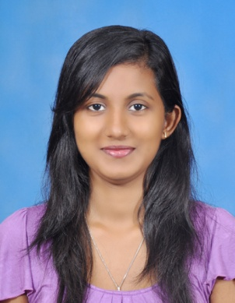**J.A.D DINUSHA JAYASINGHE**

**No.363/8, Polhena Road, Kelaniya.**

**E-mail:dinusha_rockz95@yahoo.com**

**Contact No: 011-4934920, 071-5750490, 071-8265754**

* ***Career Objective***

*Enthusiastic, energetic, innovative and responsible personality that wish to impart my knowledge and skills for the development and for the betterment of the organization and bring out the best productivity that I can ever offer for the prestigious company, and to grow for the betterment, personally and professionally*

.

* ***Personal***
* Name in full: Jayasinghe Arachchige Don Dinusha Chathurangani
* Name with initials: J.A.D Dinusha Chathurangani
* Sex: Female
* Date of birth: 09th of September 1993
* Civil Status: Single
* N.I.C No: 937530595v
* School Attended: St Bridget’s Convent
* Nationality: Sri Lankan
* ***Educational Qualifications***
* ***G.C.E(O/L)-2009***

English A Dancing C

Mathematics C Commerce C

Sinhala C Home science C

Catholicism C Science S

* ***G.C.E(A/L)-2012)***

Accounts C

Business Studies S

Economics S

* Completed a Course in ***Basic in MS office*** at St Bridget’s Convent Computer Center.
* Followed ***CIMA*** foundation at Achievers.
* Currently reading for the ***BSc applied accounting degree*** at Institute of Chartered accountants of Sri Lanka.
* ***Extra-curricular Activities***
* Participated in Annual Inter House sports meet
* Member of school bank
* Member of school Hewisi Band
* Participated in Home Economics Exhibitions and Days
* Member of school bank sacred Heart Society
* ***Experience***
* **Walkers Tours Limited**

Walkers Tours is a Destination Management Company

* + Position : Finance Assistant
  + Period : 06th November 2012 to date
  + Reported To : Accountant
  + System Used : SAP / Tour Plan
* ***Referees***

Kanchana Perera

General Manager,

S.S.T Property Developers Pvt.LTD,

103 St Joseph Street,

Grandpass,

Colombo 14.

Tel: 0773721401

Email: kanchi_the_1@yahoo.com

Shiven Perera

Propriety

S.K. Enterprises,

390 Gorge R De Silva Mawatha,

Colombo 13.

Tel: 077766852

Email:[shiven.p10@gmail.com](mailto:shiven.p10@gmail.com)

**I hereby certify that above given information is true and accurate to the best**

**of my knowledge.**

…………………………………………. …………………………………………..

**Date Dinusha Jayasinghe**